Homework Set 1

- Two schoolchildren race across a playground for a ball. Tim starts running at a distance of 15 m from the ball, Jan starts running at a distance of 12 m from the ball. If Tim’s average speed is 4.5 m/s and Jan’s average speed is 4.0 m/s, which child will reach the ball first? Show how you arrived at the answer.

Solution
Linear motion.
Tim speed=4.5m/s
Jan speed=4.0m/s
Time taken by Jan to reach the ball =$\frac{distance}{speed}$=$\frac{12}{4}$= 3seconds
Time taken by Tim to reach the ball =$\frac{distance}{speed}$=$\frac{15}{4.5}$= 3.3seconds
Relative velocity=4.5-4.0=0.5m/s
Time taken Tim to overtake Jan=$\frac{distance}{r. velocity}$= $\frac{d}{r.v}$=$\frac{3}{0.5}$=6 seconds

Jan reached the ball first
Reason
time was not able to overtake Jan before he reached the ball, he could only overtake him after 6 seconds.

2. The two short sides of a right triangle ABC (shown below) is A = 3 cm and B = 4 cm long, respectively. What is the length of the hypotenuse C? What is the value in degrees for angle α?

α
Solution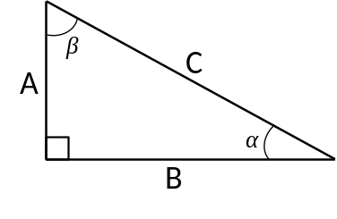
By Pythagoras theorem
C²=A²+B²
C²=3²+4²
C²=25
C=$\sqrt{25}$ =5cm
, the value of α Sinα=$\frac{opposite}{hypotenuse}$ =$\frac{3}{5}$=0.5
Sin⁻¹ α =30⁰

3. Within the triangle shown below, the length of B = 17 cm, C = 11 cm, and α = 53 degrees. What is the length of side A? What are the values in degrees for angles β and γ? (Law of Cosines)

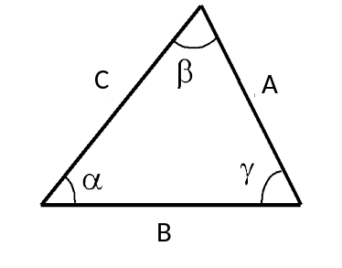
Solution
Using cosine rule, A²=B²+C²-2ABcos α
A²=17²+11²-2*17*11 cos53⁰
A²⁼289+121-374*0.60151
A²=154.92
A=$\sqrt{154.92}$
A=12.45CM
Values of γ
Through cosine rule, C²=A²+B²-2ABcos γ
11²=12.45²+17²-2ABcos γ
121-444=-423.3cos γ
cos γ=$\frac{-323}{-423.3}$=0.763052208
cos⁻¹ γ =40.27⁰
the value of β
γ+β+α=180⁰
180-(40.27⁰+53⁰)= β
β =86.73⁰

4. What is the length of the femur shown below? What is the value of angle θ in degrees?
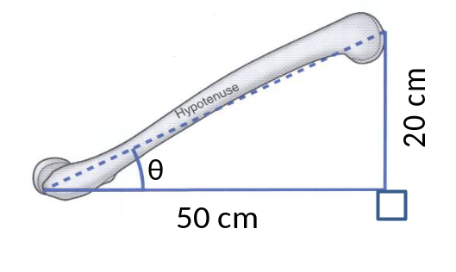
Through Pythagoras theorem,
(Hypotenuse)²=20²+50²
(Hypotenuse)²=2900
Hypotenuse=$\sqrt{2900}$
Hypotenuse=53.85cm
5. Define Biomechanics.
Biomechanics is the study of motion, structure and function of mechanical units of biological systems, at any level from cells, cell organelles to whole organs using mechanical methods.

6. Mark the activities in which the bio mechanists might be interested by placing “Yes” in the last column.
Num | Activities | Yes or No
1 | Improving a softball player’s swing | Yes
2 | Employees’ sign-in record | No
3 | The stiffness and stress of the cellular membrane of plants | yes
4 | The flight of hawks | yes
5 | Modifying a hammer-thrower’s throw technique | Yes
6 | A turkey’s gait on treadmill | Yes
7 | Changing a quarterback’s throw | Yes
8 | Altering the starting order of a basketball team | Yes
9 | How to increase the friction force to prevent older adults from falling | Yes
10 | Design a bridge which can sustain 100-ton force | No

